**Unit - V: Exploring cloud services**

Software as a Service – Overview

SaaS is also known as "**On-Demand Software**". It is a software distribution model in which services are hosted by a cloud service provider. These services are available to end-users over the internet so, the end-users do not need to install any software on their devices to access these services.

There are the following services provided by SaaS providers -

**Business Services** - SaaS Provider provides various business services to start-up the business. The SaaS business services include **ERP** (Enterprise Resource Planning), **CRM** (Customer Relationship Management), **billing**, and **sales**.

**Document Management** - SaaS document management is a software application offered by a third party (SaaS providers) to create, manage, and track electronic documents.

**Example:** Slack, Samepage, Box, and Zoho Forms.

**Social Networks** - As we all know, social networking sites are used by the general public, so social networking service providers use SaaS for their convenience and handle the general public's information.

**Mail Services** - To handle the unpredictable number of users and load on e-mail services, many e-mail providers offering their services using SaaS.

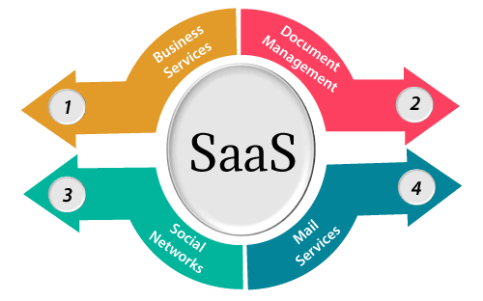

## **Advantages of SaaS cloud computing layer**

**1) SaaS is easy to buy**

SaaS pricing is based on a monthly fee or annual fee subscription, so it allows organizations to access business functionality at a low cost, which is less than licensed applications.

Unlike traditional software, which is sold as a licensed based with an up-front cost (and often an optional ongoing support fee), SaaS providers are generally pricing the applications using a subscription fee, most commonly a monthly or annually fee.

**2. One to Many**

SaaS services are offered as a one-to-many model means a single instance of the application is shared by multiple users.

**3. Less hardware required for SaaS**

The software is hosted remotely, so organizations do not need to invest in additional hardware.

**4. Low maintenance required for SaaS**

Software as a service removes the need for installation, set-up, and daily maintenance for the organizations. The initial set-up cost for SaaS is typically less than the enterprise software. SaaS vendors are pricing their applications based on some usage parameters, such as a number of users using the application. So SaaS does easy to monitor and automatic updates.

**5. No special software or hardware versions required**

All users will have the same version of the software and typically access it through the web browser. SaaS reduces IT support costs by outsourcing hardware and software maintenance and support to the IaaS provider.

**6. Multidevice support**

SaaS services can be accessed from any device such as desktops, laptops, tablets, phones, and thin clients.

**7. API Integration**

SaaS services easily integrate with other software or services through standard APIs.

**8. No client-side installation**

SaaS services are accessed directly from the service provider using the internet connection, so do not need to require any software installation.

## **Disadvantages of SaaS cloud computing layer**

**1) Security**

Actually, data is stored in the cloud, so security may be an issue for some users. However, cloud computing is not more secure than in-house deployment.

**2) Latency issue**

Since data and applications are stored in the cloud at a variable distance from the end-user, there is a possibility that there may be greater latency when interacting with the application compared to local deployment. Therefore, the SaaS model is not suitable for applications whose demand response time is in milliseconds.

**3) Total Dependency on Internet**

Without an internet connection, most SaaS applications are not usable.

**4) Switching between SaaS vendors is difficult**

Switching SaaS vendors involves the difficult and slow task of transferring the very large data files over the internet and then converting and importing them into another SaaS also.

## **Popular SaaS Providers**

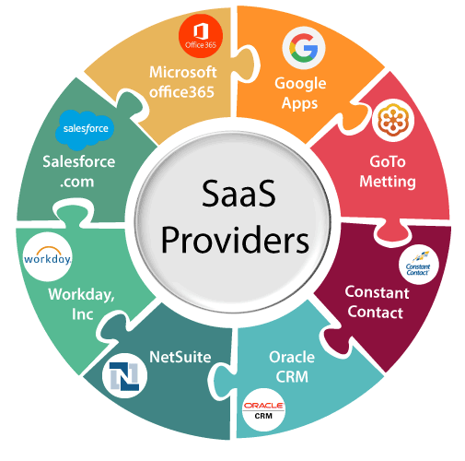

The below table shows some popular SaaS providers and services that are provided by them -

|  |  |
| --- | --- |
| **Provider** | **Services** |
| Salseforce.com | On-demand CRM solutions |
| Microsoft Office 365 | Online office suite |
| Google Apps | Gmail, Google Calendar, Docs, and sites |
| NetSuite | ERP, accounting, order management, CRM, Professionals Services Automation (PSA), and e-commerce applications. |
| GoToMeeting | Online meeting and video-conferencing software |
| Constant Contact | E-mail marketing, online survey, and event marketing |
| Oracle CRM | CRM applications |
| Workday, Inc | Human capital management, payroll, and financial management. |

# **Platform as a Service | PaaS**

Platform as a Service (PaaS) provides a runtime environment. It allows programmers to easily create, test, run, and deploy web applications. You can purchase these applications from a cloud service provider on a pay-as-per use basis and access them using the Internet connection. In PaaS, back end scalability is managed by the cloud service provider, so end- users do not need to worry about managing the infrastructure.

PaaS includes infrastructure (servers, storage, and networking) and platform (middleware, development tools, database management systems, business intelligence, and more) to support the web application life cycle.

**Example:** Google App Engine, Force.com, Joyent, Azure.

PaaS providers provide the Programming languages, Application frameworks, Databases, and Other tools:

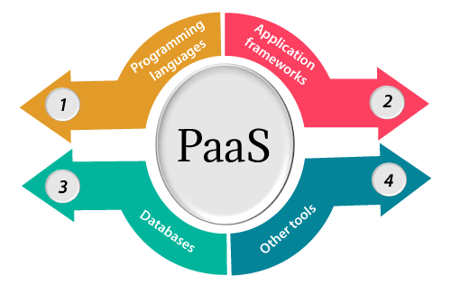

### 1. Programming languages

PaaS providers provide various programming languages for the developers to develop the applications. Some popular programming languages provided by PaaS providers are Java, PHP, Ruby, Perl, and Go.

### 2. Application frameworks

PaaS providers provide application frameworks to easily understand the application development. Some popular application frameworks provided by PaaS providers are Node.js, Drupal, Joomla, WordPress, Spring, Play, Rack, and Zend.

### 3. Databases

PaaS providers provide various databases such as ClearDB, PostgreSQL, MongoDB, and Redis to co–mmunicate with the applications.

### 4. Other tools

PaaS providers provide various other tools that are required to develop, test, and deploy the applications.

## **Advantages of PaaS**

There are the following advantages of PaaS -

**1) Simplified Development**

PaaS allows developers to focus on development and innovation without worrying about infrastructure management.

**2) Lower risk**

No need for up-front investment in hardware and software. Developers only need a PC and an internet connection to start building applications.

**3) Prebuilt business functionality**

Some PaaS vendors also provide already defined business functionality so that users can avoid building everything from very scratch and hence can directly start the projects only.

**4) Instant community**

PaaS vendors frequently provide online communities where the developer can get the ideas to share experiences and seek advice from others.

**5) Scalability**

Applications deployed can scale from one to thousands of users without any changes to the applications.

## **Disadvantages of PaaS cloud computing layer**

**1) Vendor lock-in**

One has to write the applications according to the platform provided by the PaaS vendor, so the migration of an application to another PaaS vendor would be a problem.

**2) Data Privacy**

Corporate data, whether it can be critical or not, will be private, so if it is not located within the walls of the company, there can be a risk in terms of privacy of data.

**3) Integration with the rest of the systems applications**

It may happen that some applications are local, and some are in the cloud. So there will be chances of increased complexity when we want to use data which in the cloud with the local data.

## **Popular PaaS Providers**

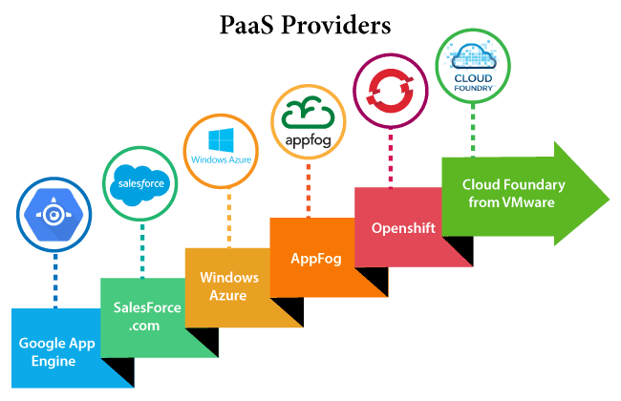

The below table shows some popular PaaS providers and services that are provided by them -

|  |  |
| --- | --- |
| **Providers** | **Services** |
| Google App Engine (GAE) | App Identity, URL Fetch, Cloud storage client library, Logservice |
| Salesforce.com | Faster implementation, Rapid scalability, CRM Services, Sales cloud, Mobile connectivity, Chatter. |
| Windows Azure | Compute, security, IoT, Data Storage. |
| AppFog | Justcloud.com, SkyDrive, GoogleDocs |
| Openshift | RedHat, Microsoft Azure. |
| Cloud Foundry from VMware | Data, Messaging, and other services. |

**PaaS application frameworks – Drupal**

Drupal is a flexible CMS based on the LAMP stack, with a modular design allowing features to be added and removed by installing and uninstalling *modules*, and allowing the entire look and feel of the website to be changed by installing and uninstalling *themes*. The base Drupal download, known as Drupal Core, contains the PHP scripts needed to run the basic CMS functionality, several optional modules and themes, and many JavaScript, CSS, and image assets. Many additional modules and themes can be downloaded from the [*Drupal.org*](https://www.drupal.org/) website.

Drupal can also run on other technology stacks:

* The operating system can be Windows or Mac OS instead of Linux.
* The web server can be Nginx or IIS instead of Apache.
* The database can be PostgreSQL or SQLite instead of MySQL, or a MySQL-compatible replacement such as MariaDB or Percona.

Other operating systems, web servers, and databases can also be made to work; however, the scripts that the software uses are written in PHP, so that cannot be changed.

The standard release of Drupal, known as Drupal core, contains basic features common to [content-management systems](https://en.wikipedia.org/wiki/Content_management_system). These include user account registration and maintenance, menu management, [RSS](https://en.wikipedia.org/wiki/RSS) feeds, taxonomy, page layout customization, and system administration. The Drupal core installation can serve as a simple website, a single- or multi-user blog, an [Internet forum](https://en.wikipedia.org/wiki/Internet_forum), or a community website providing for [user-generated content](https://en.wikipedia.org/wiki/User-generated_content).

Drupal also describes itself as a [Web application framework](https://en.wikipedia.org/wiki/Web_application_framework). When compared with notable frameworks, Drupal meets most of the generally accepted [feature requirements](https://en.wikipedia.org/wiki/Web_application_framework#Features) for such web frameworks. Although Drupal offers a sophisticated [API](https://en.wikipedia.org/wiki/Application_programming_interface) for developers, basic Web-site installation and administration of the framework require no programming skills. Drupal runs on any [computing platform](https://en.wikipedia.org/wiki/Computing_platform) that supports both a [web server](https://en.wikipedia.org/wiki/Web_server) capable of running PHP and a [database](https://en.wikipedia.org/wiki/Database) to store content and configuration.

**Core modules**[

Drupal core includes modules that can be enabled by the administrator to extend the functionality of the core website

The core Drupal distribution provides a number of features, including:

* Access statistics and logging
* Advanced search
* Books, comments, and forums
* Caching, lazy-loading content (using BigPipe) and feature throttling for improved performance
* Custom content type and fields, and user interface to create, manage, and display lists of content.
* Descriptive URLs
* Multi-level menu system
* Multi-site support
* Multi-user content creation and editing
* RSS feed and feed aggregator
* Security and new release update notification
* User profiles
* Various access control restrictions (user roles, IP addresses, email)
* Workflow tools (triggers and actions)

**Core themes**

Drupal includes core themes, which customize the "look and feel" of Drupal sites,[[62]](https://en.wikipedia.org/wiki/Drupal" \l "cite_note-coretheme-62) for example, Garland and Bartik.

The Color Module, introduced in Drupal core 5.0, allows administrators to change the color scheme of certain themes via a browser interface.[[63]](https://en.wikipedia.org/wiki/Drupal#cite_note-colormodule-63)

**Localization**

As of September 2022, Drupal is available in 100 languages including English (the default). Support is included for right-to-left languages such as [Arabic](https://en.wikipedia.org/wiki/Arabic_language), [Persian](https://en.wikipedia.org/wiki/Persian_language), and [Hebrew](https://en.wikipedia.org/wiki/Hebrew_language).

Drupal localization is built on top of [gettext](https://en.wikipedia.org/wiki/Gettext" \o "Gettext), the GNU [internationalization and localization](https://en.wikipedia.org/wiki/Internationalization_and_localization) (i18n) library.

**Auto-update notification**

Drupal can automatically notify the administrator about new versions of modules, themes, or the Drupal core. It's important to update quickly after security updates are released.

Before updating it is highly recommended to take backup of core, modules, theme, files and database. If there is any error shown after update or if the new update is not compatible with a module, then it can be quickly replaced by backup. There are several backup modules available in Drupal.

On 15 October 2014, an SQL injection vulnerability was announced and update released. Two weeks later the Drupal security team released an advisory explaining that everyone should act under the assumption that any site not updated within 7 hours of the announcement were compromised by automated attacks. Thus, it can be extremely important to apply these updates quickly and usage of a tool like [drush](https://en.wikipedia.org/wiki/Drush" \o "Drush) to make this process easier is highly recommended.

**Database abstraction**

Prior to version 7, Drupal had functions that performed tasks related to databases, such as SQL query cleansing, multi-site table name prefixing, and generating proper SQL queries. In particular, Drupal 6 introduced an abstraction layer that allowed programmers to create SQL queries without writing SQL.

Drupal 9 extends the data abstraction layer so that a programmer no longer needs to write SQL queries as text strings. It uses [PHP Data Objects](https://en.wikipedia.org/wiki/PHP_Data_Objects) to abstract the database. [Microsoft](https://en.wikipedia.org/wiki/Microsoft) has written a database driver for their [SQL Server](https://en.wikipedia.org/wiki/Microsoft_SQL_Server). Drupal 7 supports the file-based [SQLite](https://en.wikipedia.org/wiki/SQLite) database engine, which is part of the standard PHP distribution.

**Windows development**[[edit](https://en.wikipedia.org/w/index.php?title=Drupal&action=edit&section=8" \o "Edit section: Windows development)]

With Drupal 9's new database abstraction layer, and ability to run on the Windows web server [IIS](https://en.wikipedia.org/wiki/Internet_Information_Services), it is now easier for Windows developers to participate in the Drupal community.

A group on Drupal.org is dedicated to Windows issues.

**Accessibility**

Since the release of Drupal 7, [Web accessibility](https://en.wikipedia.org/wiki/Web_accessibility) has been constantly improving in the Drupal community. Drupal is a good framework for building sites accessible to people with disabilities, because many of the best practices have been incorporated into Drupal Core.

Drupal 8 saw many improvements from the [Authoring Tool Accessibility Guidelines](https://en.wikipedia.org/wiki/Authoring_Tool_Accessibility_Guidelines) (ATAG) 2.0 guidelines which support both an accessible authoring environment as well as support for authors to produce more accessible content.

The accessibility team is carrying on the work of identifying and resolving accessibility barriers and raising awareness within the community.

Drupal 8 has good semantic support for [rich web applications](https://en.wikipedia.org/wiki/Rich_web_applications) through [WAI-ARIA](https://en.wikipedia.org/wiki/WAI-ARIA). There have been many improvements to both the visitor and administrator sides of Drupal, especially:

* Drag and drop functionality;
* Improved color contrast and intensity;
* Adding skip navigation to core themes;
* Adding labels by default for input forms;
* Fixing CSS display:none with consistent methods for hiding and exposing text on focus;
* Adding support for ARIA Live Regions with Drupal.announce(); and
* Adding a TabbingManager to support better keyboard navigation.

The community also added an accessibility gate for core issues in Drupal 8.

**Case study - Google Apps and Web Services**

**Google Apps:**

**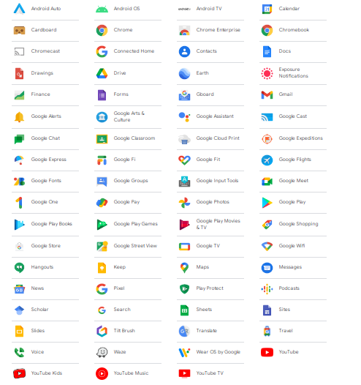**

**Web Services:**

**Google Cloud Platform** (**GCP**), offered by [Google](https://en.wikipedia.org/wiki/Google), is a suite of [cloud computing](https://en.wikipedia.org/wiki/Cloud_computing) services that runs on the same infrastructure that Google uses internally for its end-user products, such as [Google Search](https://en.wikipedia.org/wiki/Google_Search), [Gmail](https://en.wikipedia.org/wiki/Gmail), [Google Drive](https://en.wikipedia.org/wiki/Google_Drive), and [YouTube](https://en.wikipedia.org/wiki/YouTube). Alongside a set of management tools, it provides a series of modular cloud services including computing, [data storage](https://en.wikipedia.org/wiki/Computer_data_storage), [data analytics](https://en.wikipedia.org/wiki/Data_analysis) and [machine learning](https://en.wikipedia.org/wiki/Machine_learning).[[3]](https://en.wikipedia.org/wiki/Google_Cloud_Platform#cite_note-auto-3) Registration requires a [credit card](https://en.wikipedia.org/wiki/Credit_card) or bank account details.

Google Cloud Platform provides [infrastructure as a service](https://en.wikipedia.org/wiki/Infrastructure_as_a_service), [platform as a service](https://en.wikipedia.org/wiki/Platform_as_a_service), and [serverless computing](https://en.wikipedia.org/wiki/Serverless_computing" \o "Serverless computing) environments.

In April 2008, Google announced [App Engine](https://en.wikipedia.org/wiki/Google_App_Engine), a platform for developing and hosting web applications in Google-managed [data centers](https://en.wikipedia.org/wiki/Data_center), which was the first cloud computing service from the company. The service became generally available in November 2011. Since the announcement of App Engine, Google added multiple cloud services to the platform.

Google Cloud Platform is a partof **Google Cloud**, which includes the Google Cloud Platform public cloud infrastructure, as well as [Google Workspace](https://en.wikipedia.org/wiki/Google_Workspace) (G Suite), enterprise versions of [Android](https://en.wikipedia.org/wiki/Android_(operating_system)) and [Chrome OS](https://en.wikipedia.org/wiki/Chrome_OS), and [application programming interfaces (APIs)](https://en.wikipedia.org/wiki/Application_programming_interface) for [machine learning](https://en.wikipedia.org/wiki/Machine_learning) and enterprise mapping services.

### Compute

* [App Engine](https://en.wikipedia.org/wiki/Google_App_Engine) - [Platform as a Service](https://en.wikipedia.org/wiki/Platform_as_a_service) to deploy [Java](https://en.wikipedia.org/wiki/Java_(programming_language)), [PHP](https://en.wikipedia.org/wiki/PHP), [Node.js](https://en.wikipedia.org/wiki/Node.js), [Python](https://en.wikipedia.org/wiki/Python_(programming_language)), [C#](https://en.wikipedia.org/wiki/C_Sharp_(programming_language)), [.Net](https://en.wikipedia.org/wiki/.NET_Framework), [Ruby](https://en.wikipedia.org/wiki/Ruby_(programming_language)) and [Go](https://en.wikipedia.org/wiki/Go_(programming_language)) applications.
* [Compute Engine](https://en.wikipedia.org/wiki/Google_Compute_Engine) - [Infrastructure as a Service](https://en.wikipedia.org/wiki/Infrastructure_as_a_service) to run [Microsoft Windows](https://en.wikipedia.org/wiki/Microsoft_Windows) and [Linux](https://en.wikipedia.org/wiki/Linux) virtual machines.
* Google Kubernetes Engine (GKE) or GKE [on-prem](https://en.wikipedia.org/wiki/On-premises_software) offered as part of Anthos platform[[6]](https://en.wikipedia.org/wiki/Google_Cloud_Platform" \l "cite_note-auto2-6)[[7]](https://en.wikipedia.org/wiki/Google_Cloud_Platform#cite_note-7) - Containers as a Service based on [Kubernetes](https://en.wikipedia.org/wiki/Kubernetes).
* Cloud Functions - [Functions as a Service](https://en.wikipedia.org/wiki/Function_as_a_service) to run event-driven code written in Node.js, Java, Python, or Go.
* Cloud Run - Compute execution environment based on Knative.[[8]](https://en.wikipedia.org/wiki/Google_Cloud_Platform#cite_note-8) Offered as Cloud Run (fully managed)[[9]](https://en.wikipedia.org/wiki/Google_Cloud_Platform" \l "cite_note-auto1-9) or as Cloud Run for Anthos.[[9]](https://en.wikipedia.org/wiki/Google_Cloud_Platform#cite_note-auto1-9) Currently supports GCP, AWS and VMware management.[[10]](https://en.wikipedia.org/wiki/Google_Cloud_Platform#cite_note-10)

### Storage & Databases

* [Cloud Storage](https://en.wikipedia.org/wiki/Google_Storage) - [Object storage](https://en.wikipedia.org/wiki/Object_storage) with integrated edge caching to store [unstructured data](https://en.wikipedia.org/wiki/Unstructured_data).
* Cloud SQL - [Database as a Service](https://en.wikipedia.org/wiki/Cloud_database) based on [MySQL](https://en.wikipedia.org/wiki/MySQL), [PostgreSQL](https://en.wikipedia.org/wiki/PostgreSQL) and [Microsoft SQL Server](https://en.wikipedia.org/wiki/Microsoft_SQL_Server).
* [Cloud Bigtable](https://en.wikipedia.org/wiki/Bigtable) - Managed [NoSQL](https://en.wikipedia.org/wiki/NoSQL) database service. [Cloud Spanner](https://en.wikipedia.org/wiki/Spanner_(database)) - Horizontally scalable, strongly consistent, [relational database service](https://en.wikipedia.org/wiki/Relational_database_management_system).
* [Cloud Datastore](https://en.wikipedia.org/wiki/Google_Cloud_Datastore) - NoSQL database for web and mobile applications
* Persistent Disk - [Block storage](https://en.wikipedia.org/wiki/Block_(data_storage)) for Compute Engine virtual machines. Cloud Memorystore - Managed in-memory data store based on [Redis](https://en.wikipedia.org/wiki/Redis" \o "Redis) and [Memcached](https://en.wikipedia.org/wiki/Memcached" \o "Memcached).[[15]](https://en.wikipedia.org/wiki/Google_Cloud_Platform#cite_note-15)
* Local [SSD](https://en.wikipedia.org/wiki/Solid-state_drive): High-performance, transient, local block storage.
* Filestore: High-performance file storage for Google Cloud users. AlloyDB: Fully managed PostgreSQL database service.

### Networking

* VPC - [Virtual Private Cloud](https://en.wikipedia.org/wiki/Virtual_private_cloud) for managing the [software defined network](https://en.wikipedia.org/wiki/Software-defined_networking) of cloud resources.
* Cloud Load Balancing - Software-defined, managed service for [load balancing](https://en.wikipedia.org/wiki/Cloud_load_balancing) the traffic.
* Cloud Armor - [Web application firewall](https://en.wikipedia.org/wiki/Web_application_firewall) to protect workloads from [DDoS](https://en.wikipedia.org/wiki/Denial-of-service_attack) attacks.
* Cloud CDN - [Content Delivery Network](https://en.wikipedia.org/wiki/Content_delivery_network) based on Google's globally distributed edge points of presence.
* Cloud Interconnect - Service to connect a data center with Google Cloud Platform
* Cloud DNS - Managed, authoritative [DNS](https://en.wikipedia.org/wiki/Domain_Name_System) service running on the same infrastructure as Google.
* Network Service Tiers - Option to choose Premium vs Standard network tier for higher-performing network.

### Big Data

* [BigQuery](https://en.wikipedia.org/wiki/BigQuery) - Scalable, managed enterprise [data warehouse](https://en.wikipedia.org/wiki/Data_warehouse) for analytics.
* [Cloud Dataflow](https://en.wikipedia.org/wiki/Google_Cloud_Dataflow) - Managed service based on [Apache Beam](https://en.wikipedia.org/wiki/Apache_Beam) for stream and batch data processing.
* Dataproc - [Big data](https://en.wikipedia.org/wiki/Big_data) platform for running [Apache Hadoop](https://en.wikipedia.org/wiki/Apache_Hadoop) and [Apache Spark](https://en.wikipedia.org/wiki/Apache_Spark) jobs.
* Cloud Composer - Managed workflow orchestration service built on [Apache Airflow](https://en.wikipedia.org/wiki/Apache_Airflow).
* Cloud Datalab - Tool for [data exploration](https://en.wikipedia.org/wiki/Data_exploration), [analysis](https://en.wikipedia.org/wiki/Analysis), visualization and machine learning. This is a fully managed Jupyter Notebook service.
* Cloud Dataprep - Data service based on [Trifacta](https://en.wikipedia.org/wiki/Trifacta" \o "Trifacta) to visually explore, clean, and prepare data for analysis.
* Cloud Pub/Sub - Scalable event ingestion service based on [message queues](https://en.wikipedia.org/wiki/Message_queue).[[24]](https://en.wikipedia.org/wiki/Google_Cloud_Platform#cite_note-24)
* Cloud Data Studio - [Business intelligence](https://en.wikipedia.org/wiki/Business_intelligence) tool to visualize data through dashboards and reports.

### Cloud AI

* Cloud AutoML - Service to train and deploy custom machine learning models. As of September 2018, the service is in Beta.
* Cloud [TPU](https://en.wikipedia.org/wiki/Tensor_processing_unit) - Accelerators used by Google to train machine learning models.
* Cloud Machine Learning Engine - Managed service for training and building machine learning models based on mainstream frameworks.
* Cloud Talent Solution (formerly Cloud Job Discovery) - Service based on Google's search and machine learning capabilities for the recruiting ecosystem.
* Dialogflow Enterprise - Development environment based on Google's machine learning for building [conversational interfaces](https://en.wikipedia.org/wiki/Natural-language_user_interface).
* Cloud Natural Language - [Text analysis](https://en.wikipedia.org/wiki/Content_analysis) service based on Google [Deep Learning](https://en.wikipedia.org/wiki/Deep_learning) models.
* Cloud Speech-to-Text - [Speech to text](https://en.wikipedia.org/wiki/Speech_recognition) conversion service based on machine learning.
* Cloud Text-to-Speech - [Text to speech](https://en.wikipedia.org/wiki/Speech_synthesis) conversion service based on machine learning.
* Cloud Translation API - Service to dynamically translate between thousands of available language pairs.
* Cloud Vision API - [Image analysis](https://en.wikipedia.org/wiki/Image_analysis) service based on machine learning.
* Cloud Video Intelligence - [Video analysis](https://en.wikipedia.org/wiki/Video_content_analysis) service based on machine learning.

### Management Tools

* Operations suite (formerly [Stackdriver](https://en.wikipedia.org/wiki/Stackdriver" \o "Stackdriver) ) - Monitoring, logging, and diagnostics for applications on Google Cloud Platform and AWS.
* Cloud Deployment Manager  - Tool to deploy Google Cloud Platform resources defined in templates created in [YAML](https://en.wikipedia.org/wiki/YAML), [Python](https://en.wikipedia.org/wiki/Python_(programming_language)) or [Jinja2](https://en.wikipedia.org/wiki/Jinja_(template_engine)).
* Cloud Console - Web interface to manage Google Cloud Platform resources.
* [Cloud Shell](https://en.wikipedia.org/wiki/Google_cloud_shell) - Browser-based shell command-line access to manage Google Cloud Platform resources.
* Cloud Console Mobile App - [Android](https://en.wikipedia.org/wiki/Android_(operating_system)) and [iOS](https://en.wikipedia.org/wiki/IOS) application to manage Google Cloud Platform resources.
* Cloud APIs - [APIs](https://en.wikipedia.org/wiki/API) to programmatically access Google Cloud Platform resources

### Identity & Security

* Cloud Identity - [Single sign-on](https://en.wikipedia.org/wiki/Single_sign-on) (SSO) service based on [SAML 2.0](https://en.wikipedia.org/wiki/SAML_2.0) and [OpenID](https://en.wikipedia.org/wiki/OpenID).
* Cloud IAM - [Identity & Access Management](https://en.wikipedia.org/wiki/Identity_management) (IAM) service for defining policies based on [role-based access control](https://en.wikipedia.org/wiki/Role-based_access_control).
* Cloud Identity-Aware Proxy - Service to control access to cloud applications running on Google Cloud Platform without using a [VPN](https://en.wikipedia.org/wiki/Virtual_private_network).
* Cloud Data Loss Prevention API - Service to automatically discover, classify, and redact sensitive data.
* Security Key Enforcement - [Two-step verification](https://en.wikipedia.org/wiki/Multi-factor_authentication) service based on a security key.
* Cloud Key Management Service - Cloud-hosted key management service integrated with IAM and audit logging.
* Cloud Resource Manager - Service to manage resources by project, folder, and organization based on the hierarchy.
* Cloud Security Command Center - Security and data risk platform for data and services running in Google Cloud Platform.
* Cloud Security Scanner - Automated [vulnerability scanning](https://en.wikipedia.org/wiki/Vulnerability_(computing)) service for applications deployed in App Engine.
* Access Transparency - Near real-time audit logs providing visibility to Google Cloud Platform administrators.
* VPC Service Controls - Service to manage security perimeters for sensitive data in Google Cloud Platform services.

### IoT

* Cloud IoT Core - Secure device connection and management service for [Internet of Things](https://en.wikipedia.org/wiki/Internet_of_things).
* Edge TPU - Purpose-built ASIC designed to run inference at the edge. As of September 2018, this product is in private beta.
* Cloud IoT Edge - Brings AI to the [edge computing](https://en.wikipedia.org/wiki/Edge_computing) layer.

### API Platform

* Maps Platform - APIs for maps, routes, and places based on Google Maps.
* Apigee API Platform - Lifecycle management platform to design, secure, deploy, monitor, and scale APIs.
* API Monetization - Tool for API providers to create revenue models, reports, [payment gateways](https://en.wikipedia.org/wiki/Payment_gateway), and developer portal integrations.
* Developer Portal - Self-service platform for developers to publish and manage APIs.
* API Analytics - Service to analyse API-driven programs through monitoring, measuring, and managing APIs.
* Apigee Sense -  Enables API security by identifying and alerting administrators to suspicious API behaviours.
* Cloud Endpoints - An [NGINX](https://en.wikipedia.org/wiki/Nginx)-based proxy to deploy and manage APIs.
* Service Infrastructure - A set of foundational services for building Google Cloud products.